Foundations of Programming
Assignment No. : 01
PROBLEM STATEMENT:
Write a program in C to check whether a given year is a Leap Year
OBJECTIVE:

- To understand the use of conditional statements in C programming.
- To implement logical conditions for solving real-world problems.
- To develop problem-solving skills using decision control structures.
THEORY:
- Theory for conditional statements with syntax (if , if-else, if-else ladder) are used in C programming
- Theory for a Leap Year - year that contains 366 days instead of the usual 365 days.
Rules:
• A year is a leap year if it is divisible by 400, OR
• A year is a leap year if it is divisible by 4 but not divisible by 100.

Algorithm:
- START
- Read value of ‘a’
- If ‘a’ is divisible by by 4 but not 100 or if ‘a’ is divisible by 400 display it is a leap year.
- Else display it is not a leap year.
- STOP

PLATFORM: Linux
INPUT: Enter a year (integer value).
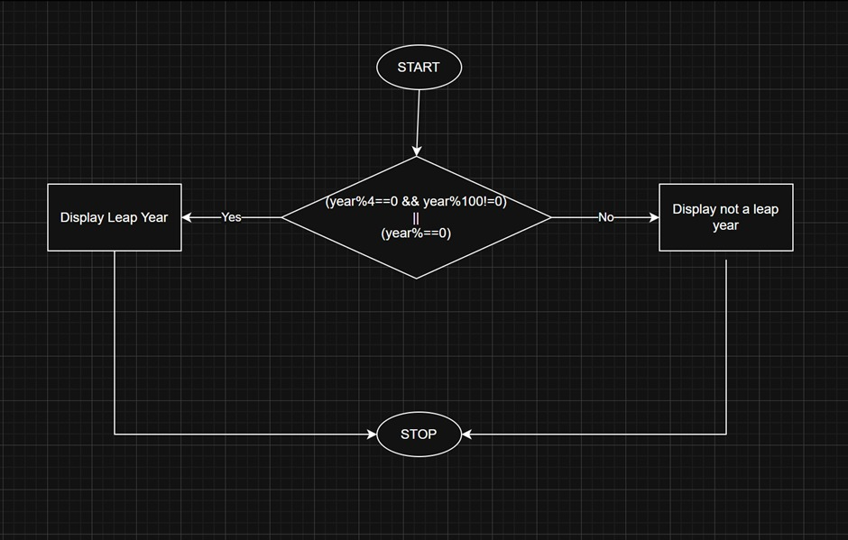

Code:
#include <stdio.h>
int main() {
int a;
scanf("%d",&a);
if((a%4==0 && a%100!=0)||a%400==0)
printf("%d is a leap year",a);
else
printf("%d is not a leap year",a);
return 0;}
Sample Input
2000
Sample Output
2000is a Leap Year
CONCLUSION: Thus, the program successfully checks whether a given year is a Leap Year using conditional statements in C.

1.What is a leap year?
A leap year is a year that has 366 days instead of 365, with an extra day added in February (29th) to keep the calendar aligned with Earth’s orbit.

2. Why is the year 1900 not a leap year but 2000 is?
A year divisible by 100 must also be divisible by 400 to be a leap year.
- 1900 is divisible by 100 but not by 400, so it is not a leap year.
- 2000 is divisible by 400, so it is a leap year.

3. Which operators are used in this program?
The program uses:
- Modulo operator (%) – to check divisibility
- Relational operators (==) – for comparisons
- Logical operators (&&, ||) – to combine conditions
4. Difference between if and if–else statements.
- if statement: Executes a block only when the condition is true.
- if–else statement: Executes one block when the condition is true and another block when it is false.

